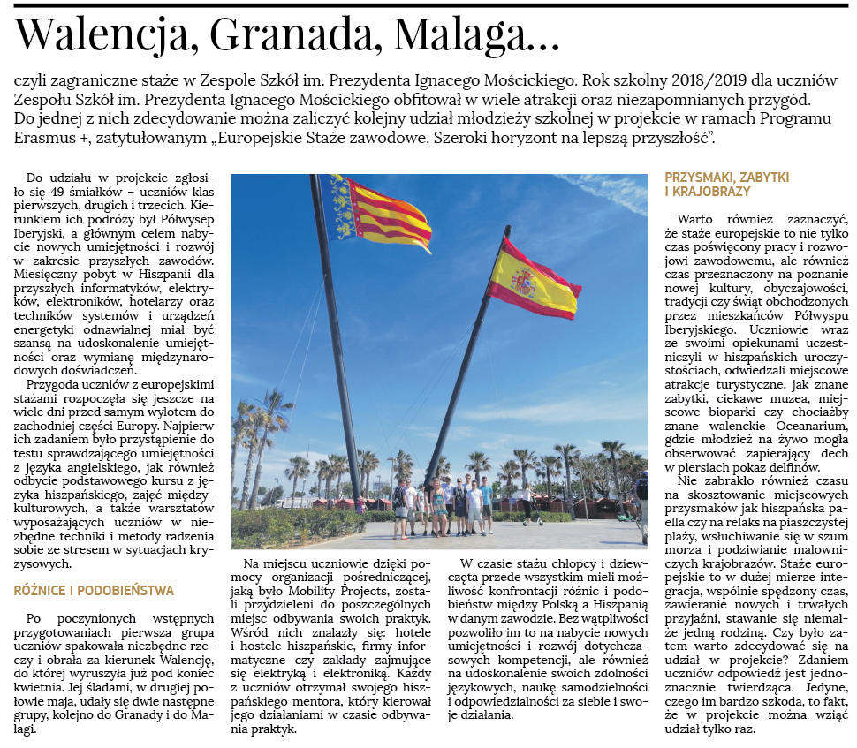
Valencia, Grenada, Malaga ...
in other words - foreign internships at President Ignacy Mościcki’s Technical Secondary School

The school year 2018/2019 for the students of President Ignacy Mościcki’s Technical Secondary School abounded in many attractions and unforgettable adventures. One of them definitely includes the next participation of the students in a project under the Erasmus + Program, entitled "European Professional Internships. A broad horizon for a better future".
49 daredevils, first, second and third grade students applied to participate in the project. The direction of their journey was the Iberian Peninsula, and the main goal was to acquire new skills and develop future professions. A one month stay in Spain for future IT specialists, electricians, electronics, hoteliers and technicians of renewable energy systems and equipment was to be an opportunity to improve skills and exchange international experiences.
The adventure of students with European internships began many days before their flight to the western part of Europe. Their first task was to take an English language test, as well as a basic Spanish course, intercultural activities and workshops to equip students with the necessary techniques and methods to deal with stress in crisis situations.
After the initial preparations, the first group of students packed the necessary things and took Valencia as their destination, to which they set off at the end of April. Similarly, in the second half of May, two more groups went to Granada and Malaga. On the spot, the students, with the help of an intermediary organisation such as Mobility Projects, were assigned to the various places where they had their apprenticeships. These included Spanish hotels and hostels, IT companies and electrical and electronic companies. Each student received a Spanish mentor who was in charge of his or her activities during the internship. During the internship, boys and girls had the opportunity to confront the differences and similarities between Poland and Spain in a given profession. Without a doubt, this allowed them to acquire new skills and develop existing competences, but also to improve their language skills, learn independence and responsibility for themselves and their actions.

It is also worth pointing out that European internships are not only the time devoted to work and professional development, but also the time spent on getting to know a new culture, customs, traditions or holidays celebrated by the inhabitants of the Iberian Peninsula. The students together with their guardians participated in Spanish celebrations, visited local tourist attractions, such as famous monuments, interesting museums, local bioparks or even the well-known Valencian Oceanarium, where young people could watch the breathtaking dolphin show live. There was also time to try local delicacies, such as Spanish paella or to relax on a sandy beach, listen to the sound of the sea and admire the picturesque landscapes. European internships are largely integration, time spent together, making new and lasting friendships, becoming almost one family.
So was it worthwhile to decide to participate in the project? In the students' opinion, the answer is clearly affirmative. The only thing they feel very sorry for is the fact that you can participate in the project only once.

